Term Four – Week Six Christmas Spiritual

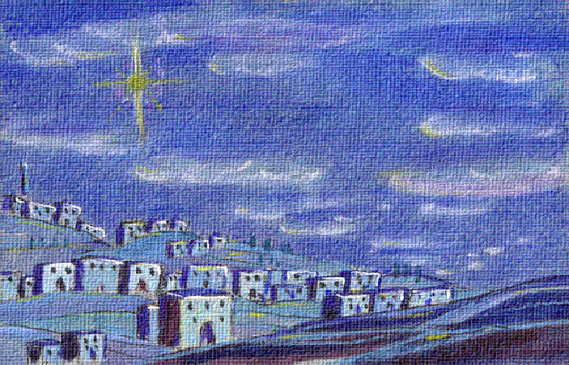
Aim: The Aim of this one week module is for the girls to find out about and celebrate the birth of Jesus Christ.

Preparation:
Set up meeting place for a birthday party e.g. balloons, streamers etc and have some party food prepared in the kitchen, or arrange for this to be brought to premises.
Practice the Christmas play (attached at end of module) for devotions. Use the leaders and perhaps other people from the church to make up the numbers if required.

Pre SetUp arrival time:
Have one leader organised to run some Christmas games before the start of your programme. (See suggestions in Games Section at the end of this book).

SetUp: 10minutes
Usual set up with the marking of rolls etc.

Main activity:

Make a Paper Wreath from Jigsaw Pieces:
Equipment needed:
- Square of Green card for each person (size 20cm x 20cm) - cut a wreath shape from the card, one for each girl.
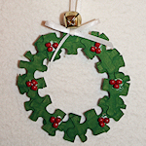
- Some green water based paint
- Newspaper or newsprint to cover tables
- A piece of red construction paper or red ribbon
- Scissors
- Glue
- Optional: Glitter or glitter glue, bells

Paint your pieces of puzzle and allow them to dry. This could be pre done by spray painting if you wish.
Glue the jigsaw pieces together in a wreath shape on the piece of green card, with the pieces overlapping a little bit.
Glue on a red ribbon bow (or make one from red construction paper).
Optional: Decorate your wreath with glitter or glitter glue.

Devotions:
Perform the play and then “have a party to celebrate”.

Finish with Closing Prayer.

Home Time & Notices

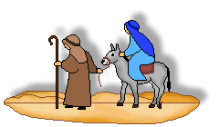
Christmas Play
Innkeeper
Mary
Joseph
3 Shepherds
3 Wise men
Angels
Narrator

Scene: Innkeeper has just gone to bed.
Narrator: There was nothing the innkeeper liked more than a good night's sleep
Innkeeper: ZZZZZZZZ (Snoring)
Narrator: And he needed it tonight, as he had been so busy with his inn completely booked. The census was taking place this month and people from all over Israel were in town. But that night there was a knock at the door.
(Knock at door by Mary, Innkeeper wakes up with a start, yawns and reluctantly goes downstairs to open the door)
Mary: Hello, I was just wondering whether you had a room available.
Innkeeper: For how many?
Mary: Do you have a room for two? My husband is....
Innkeeper: Sorry we have no room.
Mary: But we are tired and have travelled through night and day.
Innkeeper: Well there's only the stable round the back.
Mary: That would be great.
Innkeeper: Here are 2 blankets, sign the register.
Narrator: So they signed it Mary and Joseph
(Mary heads off to the stable, innkeeper returns to bed)
Narrator: He shuts the door, climbed the stairs, got into bed and went to sleep.
Innkeeper: Snores
Narrator: But then later there was another knock at the door (innkeeper answers the door)
Joseph: I was wondering whether you could lend us another smaller blanket? Mary has just....
Innkeeper: Fine, Here is one small blanket. Goodnight.
Narrator: Then he shut the door, climbed the stairs, got into bed and went to sleep.
Innkeeper: Snores
Narrator: But then a bright light woke him up.
(Torch shined in face from through window, innkeeper gets up goes outside discovers a huge bright shinning star directly over the stable.)
Innkeeper: Well that's all I need. A huge bright shinning star directly over my stable!
Narrator: Then he shut the door, climbed the stairs, drew the curtains, got into bed and went to sleep.
Innkeeper: snores
Narrator: But then there was ANOTHER knock at the door.
(Innkeeper gets out of bed to answer door)
Shepherds: We are shepherds
Innkeeper: Well what's the matter? Lost your sheep?
Shepherds: We've come to see Mary and Joseph, where are...
Innkeeper: ROUND THE BACK.
Narrator: Then he shut the door, climbed the stairs and got into bed and went to sleep.
Innkeeper: Snores
Narrator: But then there was ANOTHER knock at the door.
Innkeeper: Extremely frustrated storms to the door.
Wisemen; (cheerfully) we are wise men, we've come...
Innkeeper; ROUND THE BACK!
(Wisemen startled and hurry round the back)
Narrator: He slammed the door, climbed the stairs, got into bed and went to sleep
Innkeeper: Snores
Narrator: Bur then a chorus of singing woke him up.
(CD plays Hark the Herald or similar)
Innkeeper: RIGHT THAT DOES IT!
Narrator: So he got out of bed stomped down the stairs, threw open the door, went round the back, and was just about to speak when...
Everybody: SShhh! You'll wake the baby!
Innkeeper: (confused) Baby?
Someone: Yes a baby has been born this night.
Innkeeper: Oh! (looking crossly into the manger)
Narrator: and at just that moment, suddenly, amazingly, his anger seemed to fly away.
Innkeeper: Oh! Isn't he lovely!
Narrator: In fact he thought he was so special.... He woke up all the guests at the inn, so they could come and have a look at the baby too. So no one got that much sleep that night!
Everybody: THE END

